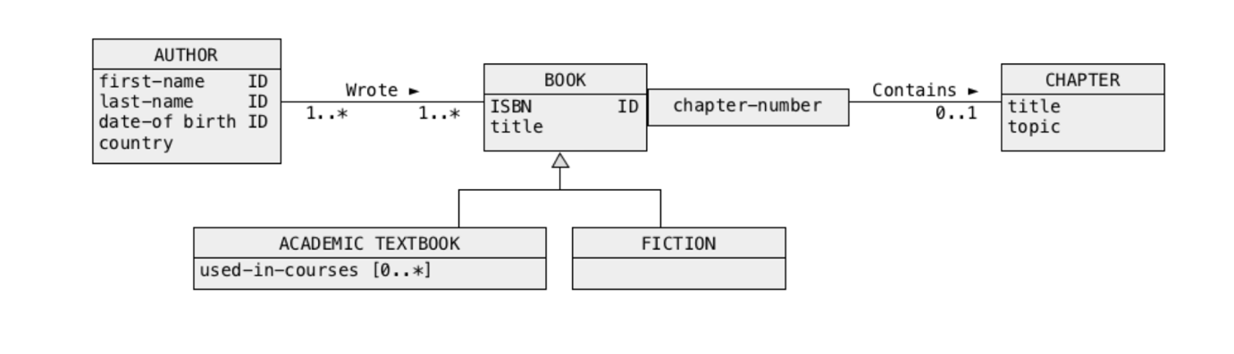**Solution3**

Superset method

1.Remove the subclasses, merge attributes into the superset BOOK, add a type of attribute **type-of-book**.

BOOK(ISBN, title, used-in-courses[0..1], type-of-book)

PRIMARY KEY = (ISBN)

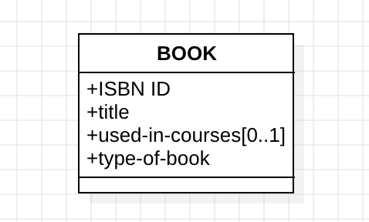

2. Handle Multi-valued Attributes **used-in-courses**, create a separate relation BOOK_COURSE for it.

BOOK_COURSE(ISBN, CourseID)

PRIMARY KEY = (ISBN, CourseID)

FOREIGN KEY = (ISBN) REFERENCES BOOK

So BOOK now is:

BOOK(ISBN, title, type-of-book)

PRIMARY KEY = (ISBN)

3.BOOK-CHAPTER is one-to-many.

CHAPTER(ChapterNumber, title, topic, ISBN)

PRIMARY KEY = (ChapterNumber, ISBN)

FOREIGN KEY = (ISBN) REFERENCES BOOK

4. An author can write many books and a book may have many authors.

AUTHOR_BOOK(AuthorID, ISBN)

PRIMARY KEY = (AuthorID, ISBN)

FOREIGN KEY = (AuthorID) REFERENCES AUTHOR

FOREIGN KEY = (ISBN) REFERENCES BOOK

5. For the many to many relation between BOOK and AUTHOR, the AUTHOR should be like:

AUTHOR(AuthorID, first-name, last-name, date-of-birth, country)

PRIMARY KEY = (AuthorID)

6. Relational Schemas

AUTHOR(AuthorID, first-name, last-name, date-of-birth, country)

PRIMARY KEY = (AuthorID)

BOOK(ISBN, title, type-of-book)

PRIMARY KEY = (ISBN)

CHAPTER(ChapterNumber, title, topic, ISBN)

PRIMARY KEY = (ChapterNumber, ISBN)

FOREIGN KEY = (ISBN) REFERENCES BOOK

BOOK_COURSE(ISBN, CourseID)

PRIMARY KEY = (ISBN, CourseID)

FOREIGN KEY = (ISBN) REFERENCES BOOK

AUTHOR_BOOK(AuthorID, ISBN)

PRIMARY KEY = (AuthorID, ISBN)

FOREIGN KEY = (AuthorID) REFERENCES AUTHOR

FOREIGN KEY = (ISBN) REFERENCES BOOK